# Lunix 软件使用

## FastQC

（运行方法之一不推荐）

1.软件运行

No.1 cd到软件目录

(base) zhangjain@zhangjain-Lenovo-Erazer-Y50-70:~$ cd ~/FastQC

No.2运行FastQC软件

(base) zhangjain@zhangjain-Lenovo-Erazer-Y50-70:~/FastQC$ ./fastqc

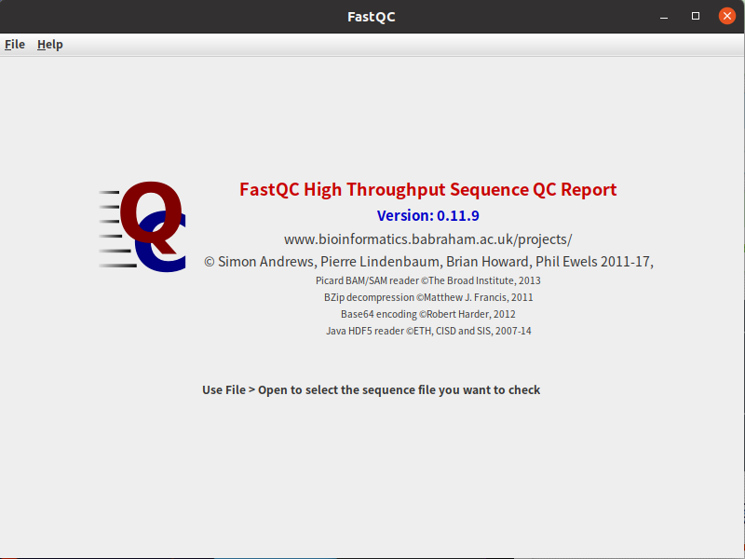

No.3开始对fasta进行质量评估

（运行方法2）推荐

No.1（已知软件安装位置）

cd 到软件安装位置（以下位置是我安装的位置不同的电脑可能不相同）

(base) zhangjain@zhangjain-Lenovo-Erazer-Y50-70:~$ cd ~/fastqc/FastQC

No.2（运行fastqc）

(base) zhangjain@zhangjain-Lenovo-Erazer-Y50-70:~/fastqc/FastQC$ ./fastqc -v

（以上为查看软件版本程序）

./fastqc -o ./ -t 2 /home/zhangjain/桌面/mirna/SRR1258335.fastq.gz /home/zhangjain/桌面/mirna/SRR1258336.fastq.gz

|  |  |  |
| --- | --- | --- |
| -h | --help | Print this help file and exit |
| -v | --version | Print the version of the program and exit |
| -o | --outdir | Create all output files in the specified output directory.Please note that this directory must exist as the program will not create it. If this option is not set then the output file for each sequence file is created in the same directory as the sequence file which was processed. |
| -t | --threads | Specifies the number of files which can be processed simultaneously. Each thread will be allocated 250MB of memory so you shouldn't run more threads than your available memory will cope with, and not more than 6 threads on a 32 bit machine |
| -q | --quiet | Supress all progress messages on stdout and only report errors. |

**运行示意图**

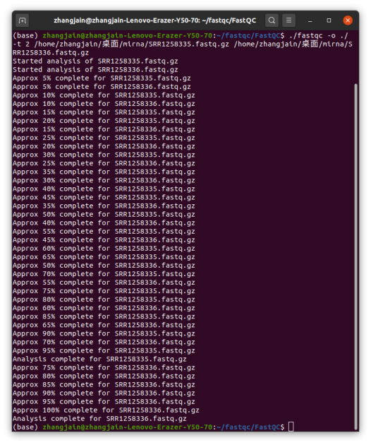

## prinseq-lite使用指南

安装：

# 进入你软件源码存放的文件夹。 cd ~/software# 下载软件 curl -OL <http://downloads.sourceforge.net/project/prinseq/standalone/prinseq-lite-0.20.4.tar.gz>

# 解压 tar zxvf prinseq-lite-0.20.4.tar.gz

# 进入文件夹 cd prinseq-lite-0.20.4ls

# 查看目录里的内容

# 把该目录下的三个 perl 脚本 (prinseq-lite.pl 、 prinseq-graphs.pl 和 prinseq-graphs-noPCA.pl ) 变得可执行。chmod +x *.pl

# 把目录 ~/software/prinseq-lite-0.20.4/ 添加到环境变量

# Mac 下:echo 'export PATH=$PATH:~/software/prinseq-lite-0.20.4/' >> ~/.profile

# 使设置生效 source~/.profile

# 在 Linux 下 :echo 'export PATH=$PATH:~/software/prinseq-lite-0.20.4/' >> ~/.bashrcsource ~/.bashrc

# 测试软件是否安装成功 prinseq-lite.pl -h

# 出现帮助文档则为安装成功。

prinseq-lite软件 要求Perl 环境

cd ~/software/prinseq-lite-0.20.4/

perl prinseq-lite.pl -fastq SRR1258336.fastq -ns_max_n 1 -out_good nfiltered -out_bad null -no_qual_header -log -verbose

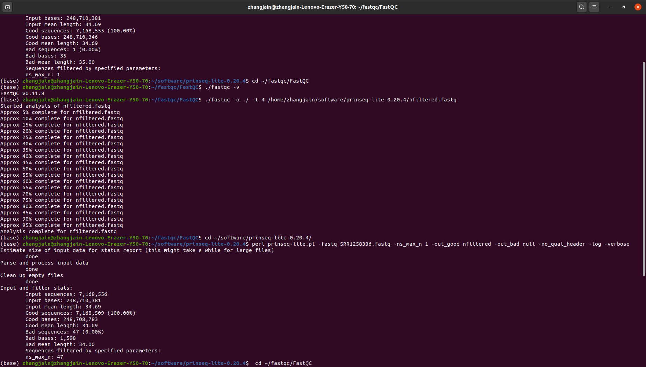

#在-fastq后面如果是OUTPUT-cut-SRR1258336.fastq 软件会找不到目录或者文件

## Cutadapt 使用要求

由于cutadapt是使用conda 安装，因此每次启动cutadapt是需要先运行cutadaptenv

## **Installation with conda**

Alternatively, Cutadapt is available as a Conda package from the [bioconda channel](https://bioconda.github.io/). [Install miniconda](http://conda.pydata.org/miniconda.html) if you don’t have Conda. Then follow the [Bioconda installation instructions](https://bioconda.github.io/user/install.html) (in particular, make sure you have both bioconda and conda-forge in your channels list).

To then install Cutadapt into a new Conda environment, use this command:

conda create -n cutadaptenv cutadapt

Here, cutadaptenv is the name of the Conda environment. (You can choose a different name.)

An environment needs to be activated every time you want to use the programs in it:

conda activate cutadaptenv

Finally, check whether it worked:

cutadapt --version

Mirtrace 安装

conda install -c bioconda mirtrace

## **miRDeep2**

安装使用conda

安装指令

conda install -c bioconda mirdeep2  
conda install -c bioconda/label/cf201901 mirdeep2

运行程序

miRDeep2.pl

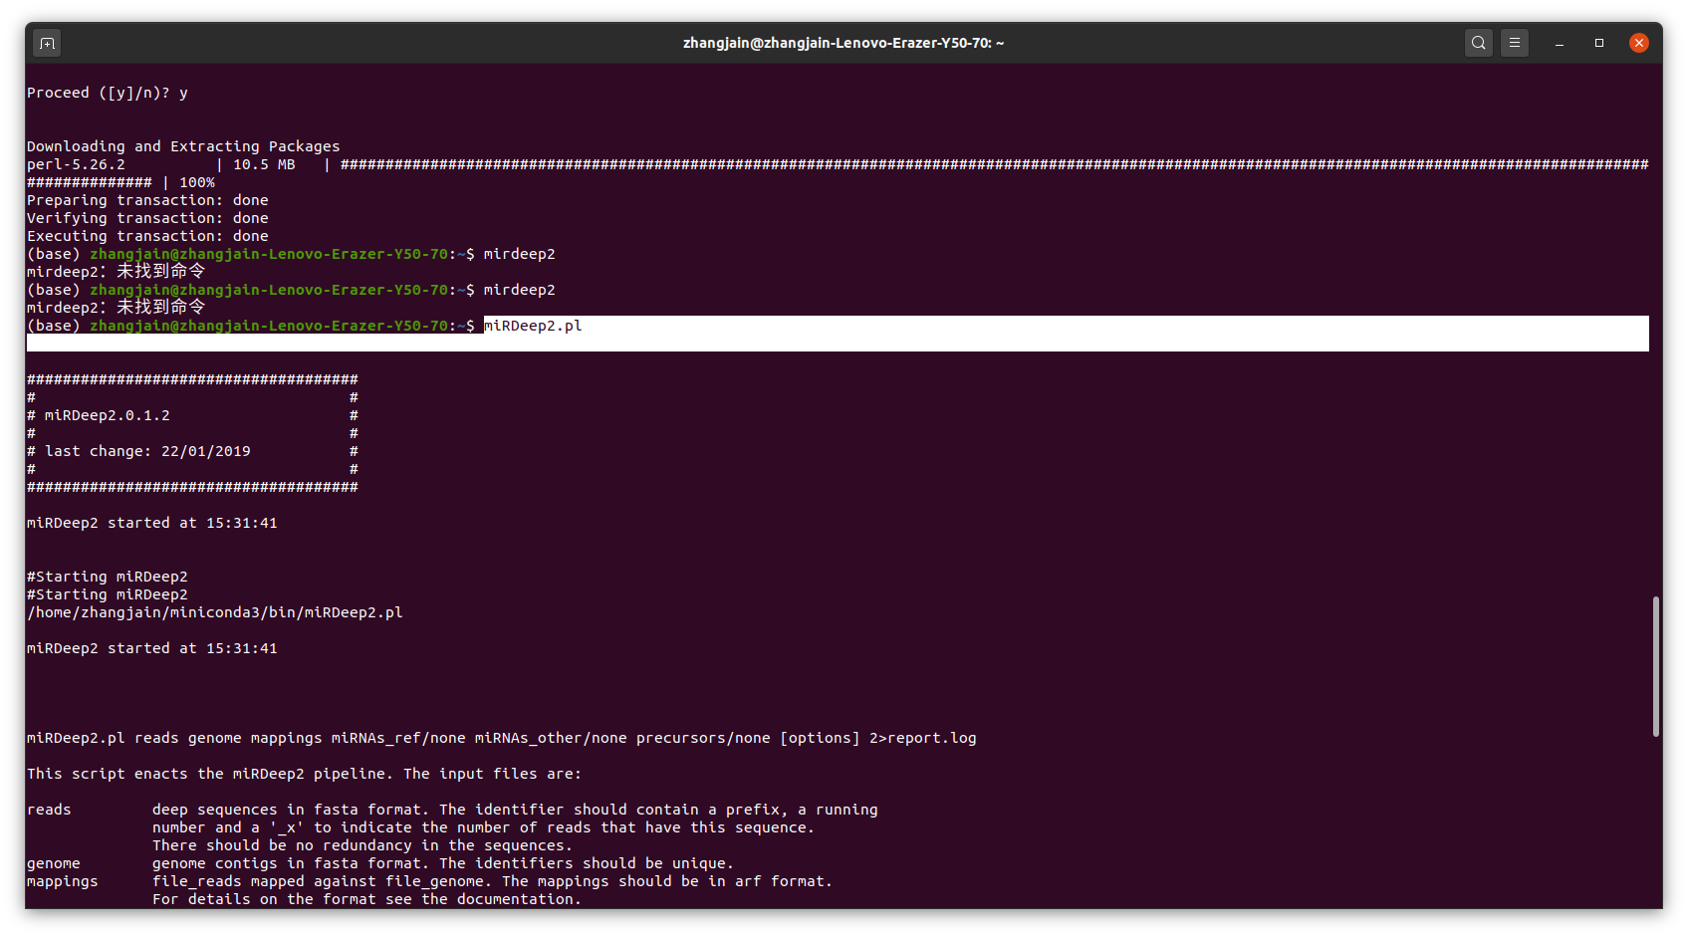

Conda 使用

Conda 安装

问题1.如果在安装软件包的时候一直提示找不到 软件包

要不就是此软件不支持conda安装

可以到以下地址进行搜索

（https://anaconda.org/bioconda/randfold）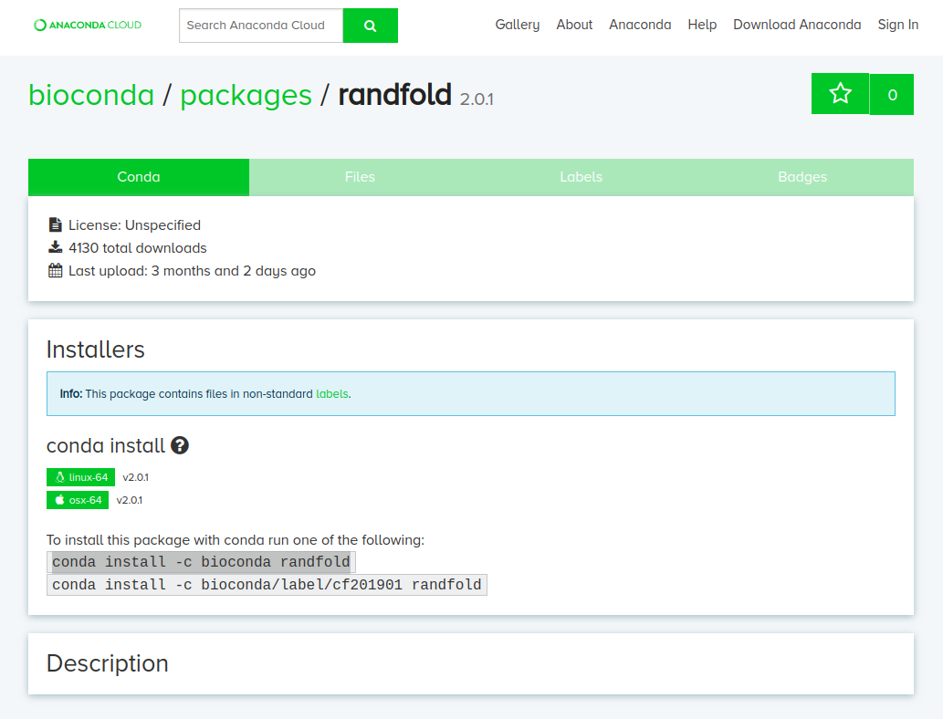

要不就是conda 源污染了

解决方法：

conda config --remove-key channels###删除所有conda源

##安装清华conda源

conda config --add channels https://mirrors.tuna.tsinghua.edu.cn/anaconda/pkgs/free/

conda config --add channels https://mirrors.tuna.tsinghua.edu.cn/anaconda/cloud/conda-forge

conda config --add channels https://mirrors.tuna.tsinghua.edu.cn/anaconda/cloud/msys2/

conda config --set show_channel_urls yes

##查看已经安装的conda源

conda config --show-sources



参考conda的安装与使用（2020-08-10更新）(https://www.jianshu.com/p/edaa744ea47d)